Day: 19 (06-11-2026) | Business insights by analysing and interpreting dashboard | Documented By:
Task – 3 | Business insights by analysing and interpreting dashboard | Sujit T K

Dashboard:
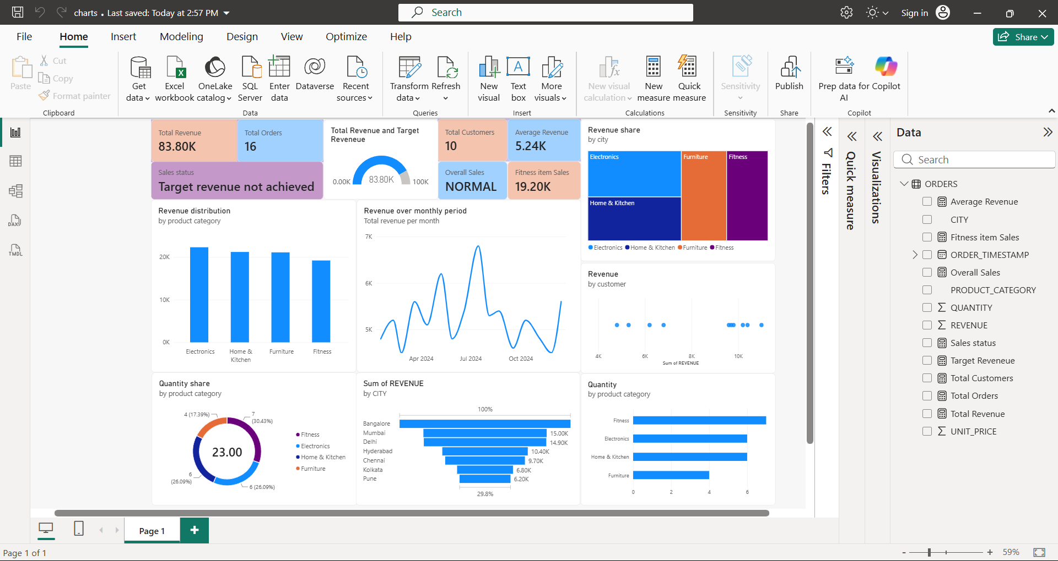
Report:
Business Storytelling with Data – Sales Performance Analysis
Insight 1: Target Revenue & Overall Performance
- Observation: Total revenue achieved stands at 83.80K against the set target of 100K across 16 orders and 10 total customers. The sales status is marked as "Target revenue not achieved," with an overall sales classification of "NORMAL."
- Interpretation: The business fell short of its revenue goal by 16.20K (achieving 83.8% of the target). While order volume and customer base remain modest, the current performance pace is stable but insufficient to hit top-line expectations.
- Recommendation: Implement targeted promotions, bundle offers, and upsell initiatives toward the existing customer base to lift average order value and close the remaining 16.2% gap.
Insight 2: Geographic Revenue Contribution
- Observation: Bangalore leads the market with the highest revenue, followed closely by Mumbai (15.00K) and Delhi (14.90K). Hyderabad (10.40K), Chennai (9.70K), Kolkata (6.80K), and Pune (6.20K) generate lower revenue shares.
- Interpretation: Bangalore, Mumbai, and Delhi together form the dominant revenue core of the business, while tier-1 and metro hubs like Kolkata and Pune are significantly underperforming in market penetration.
- Recommendation: Reinforce retention and high-value client servicing in top tier cities (Bangalore, Mumbai, Delhi) while running localized regional campaigns and channel partnerships to expand sales volume in Pune and Kolkata.
Insight 3: Product Category Revenue vs. Volume Dynamics
- Observation: Electronics leads both overall revenue distribution and tree-map revenue share, followed closely by Home & Kitchen and Furniture, with Fitness generating 19.20K. In unit volume, Fitness represents the largest share of units sold (7 units / 30.43%), followed by Electronics and Home & Kitchen (6 units / 26.09% each), and Furniture (4 units / 17.39%).
- Interpretation: Fitness products act as high-volume drivers with a lower revenue realization per unit, whereas Electronics and Furniture deliver higher ticket values despite lower unit counts.
- Recommendation: Create cross-selling bundles pairing lower-cost Fitness products with higher-margin Electronics or Home & Kitchen accessories to drive higher blended margins and order values.
Insight 4: Revenue Trend Over Monthly Period
- Observation: Monthly sales exhibit strong volatility between early 2024 and late 2024, reaching a sharp peak in mid-2024 (around June/July near 7K) before experiencing steep declines below 5K around April and October 2024.
- Interpretation: Revenue fluctuates heavily across months, indicating susceptibility to seasonality, promotional campaign dependencies, or irregular order cycles rather than sustained month-over-month growth.
- Recommendation: Establish recurring customer engagement programs, subscription models, or off-season discounts to smooth out mid-year revenue troughs and stabilize cash flow across slow quarters.
Insight 5: Customer Concentration & Average Spend
- Observation: The business generated 83.80K from 10 customers across 16 orders, resulting in an average revenue of 5.24K per customer/order metric. The customer revenue distribution shows a clear bifurcation: a cluster of customers spending between 4K–6K, and a small high-value segment spending near 10K–11K.
- Interpretation: Customer purchasing behavior is divided between entry/mid-tier buyers and a small group of premium buyers who contribute a disproportionate amount to overall top-line revenue.
- Recommendation: Launch a tiered loyalty and VIP customer program for high-ticket buyers (~10K+ segment) to drive repeat orders, while creating targeted upgrade paths to migrate the 4K–6K cluster into higher spend tiers.

